Greetings Fellow TELSTECHs
The Djinnang Association (Qld) will be holding their 2018 Annual Communicators Reunion on Sat, 26 May 18. Their function will be held at the Hotel Jen, 159 Roma St, Brisbane.

The TELSTECHs Association Committee has again decided to hold a
Reunion on the evening previous – from 1830, Fri, 25 May 18.

The last two TELSTECH Reunions were a huge success. This year’s function will be held along the same lines and at the same venue as the Communicators.
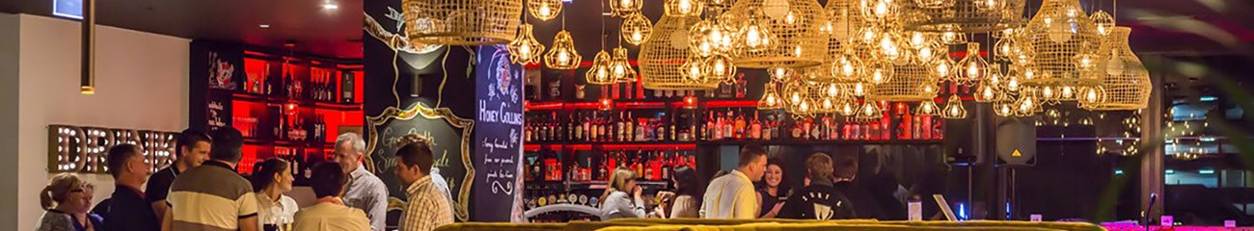
The Nest Bar & Restaurant
@ The Jen Hotel
159 Roma St, Brisbane

I will be booking a dedicated area. The plan, should you decide to come, is that your attendance can be for:
- a meal,
- a drink, or
- just to reminisce.
It’s your choice!!!
With the program being so fluid, it means that I will not be requiring money up front, but I do require numbers. So let me know if you are attending!!! My contact details are:
Mobile: 0419 805 282
Email: nippermc@hotmail.com
Website: RAAF TELSTECH Website

Regards Nipper
PS. Please pass on to, or discuss with, fellow TELSTECHs.

